END LAB TEST
PIN:2503A52L17
Q1: Implement dynamic pricing heuristic.
• Task 1: Use AI to propose algorithms balancing demand and margin.
• Task 2: Simulate with historic sales data.
Q2: Implement order route to warehouses (optimization).
• Task 1: Use AI to produce greedy and heuristic algorithms.
• Task 2: Evaluate cost and delivery time trade-offs.
Q1: 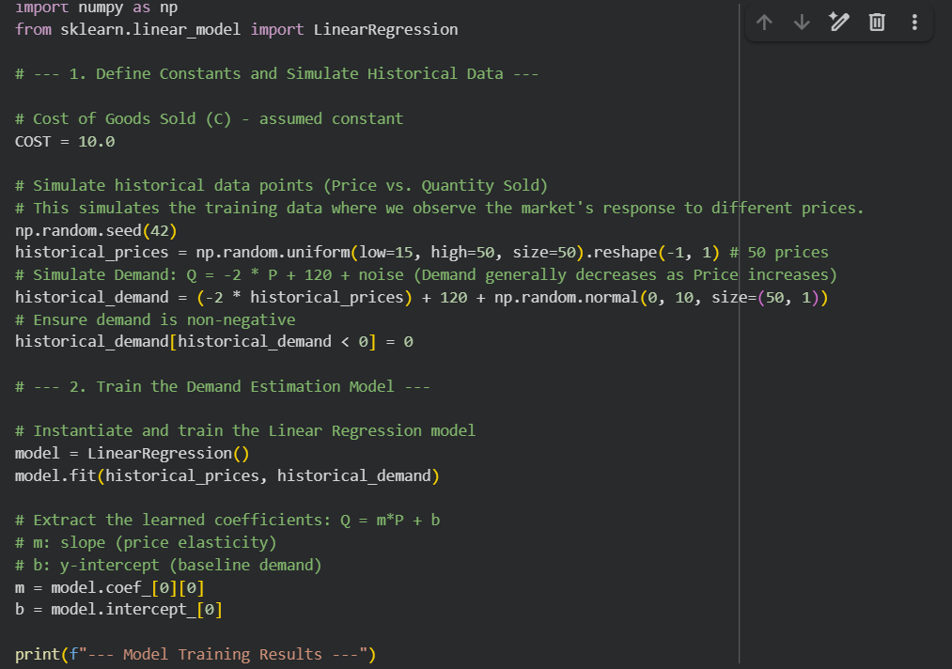

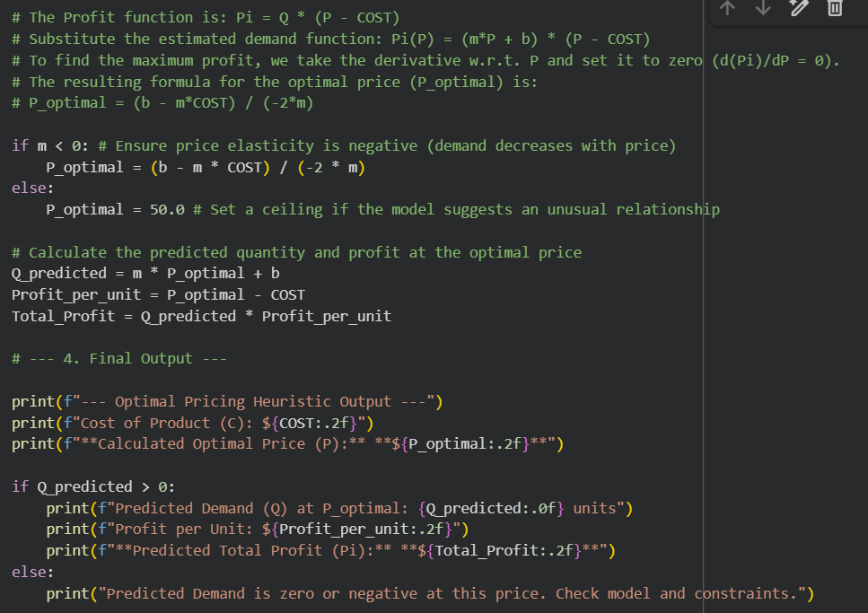
OUTPUT:
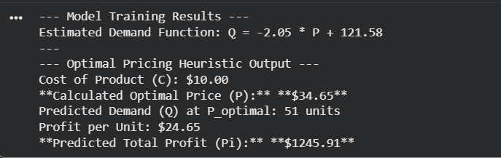

Q2:
CODE: 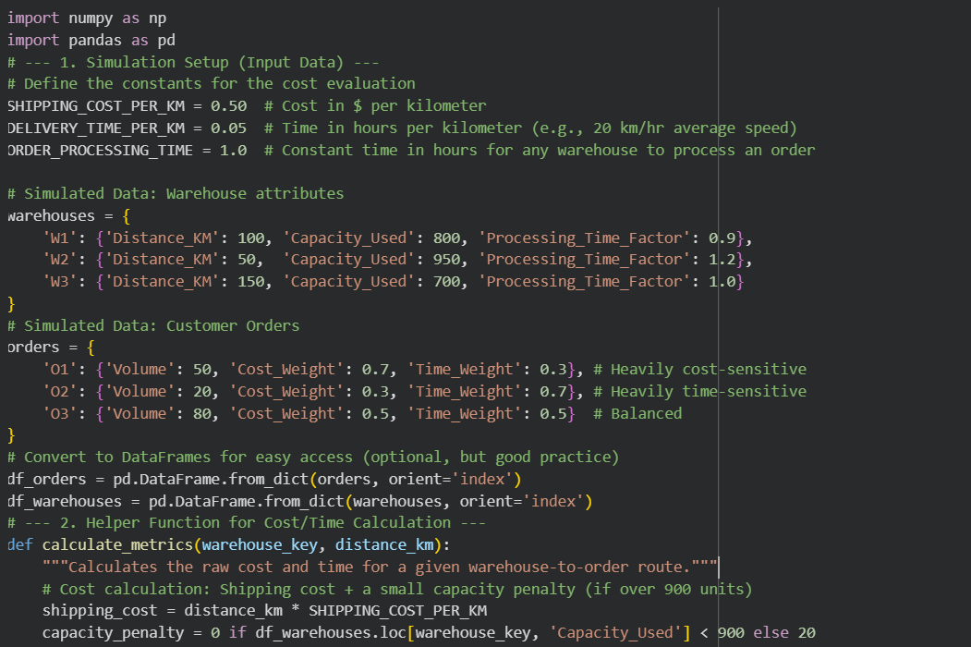
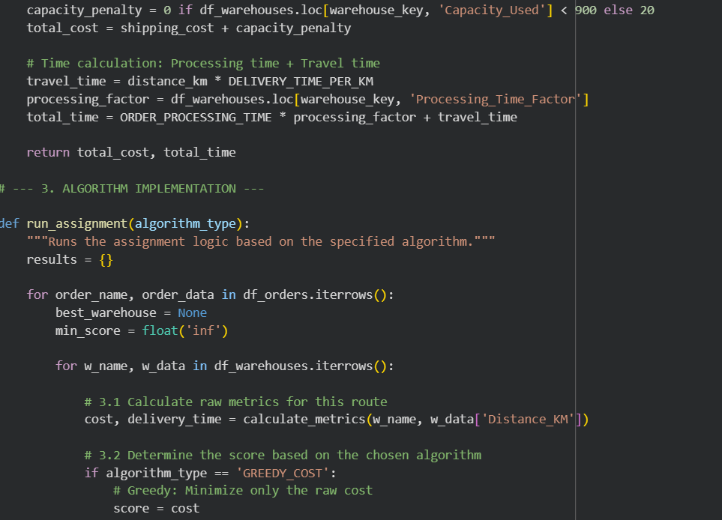
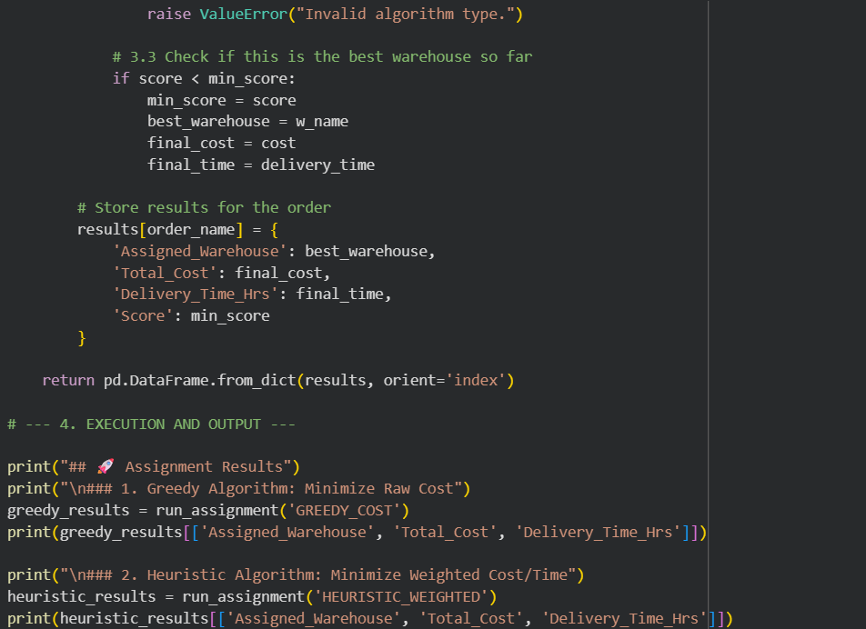
OUTPUT: 